Bulk and Retail Petroleum

Module 4

Notice of Approval

January 2021

Uncontrolled copy for training purposes only

Notice of Approval
Note: The information found on notices of approval is prescribed by section 17 of the Regulations.
Before a device can be examined for trade use, it must first have received approval by Measurement Canada. An approval number, preceded by the letters AV (Approval Volume), AM (Approval Mass) or SWA (Specifications Written Approval) is given to every approved device. For weighing devices, in some instances, class approvals are issued allowing the manufacturer to make any design of that device for which the approval is issued.

Example: Standard Approval Number
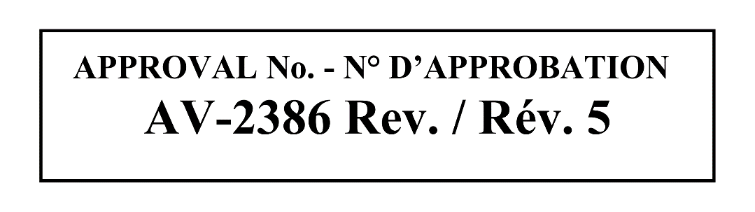
In certain circumstances where Measurement Canada is unable to test the performance of a type of device in the approvals laboratory, a special conditional approval may be issued. The inspection of these conditionally approved devices is outside the scope of the accreditation / registration program.

Example: Conditional Approval Number
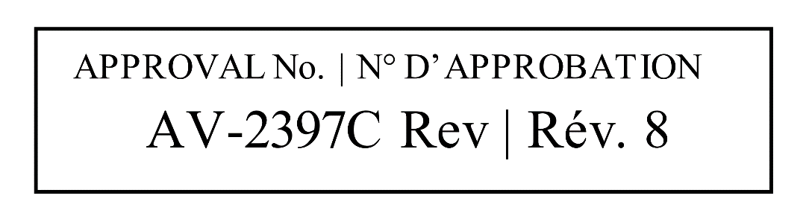
Prior to the examination of the device, the notice of approval issued by Measurement Canada must be reviewed in detail to ensure that the device under examination is in every respect identical to the unit that received approval. The notice of approval provides a detailed description of the device and, in most cases, photographs or drawings as well. The device will have all words, symbols (e.g. units of measurement, $) and legends described or depicted in the notice of approval. The notice of approval may also specify the products for which the device is approved.
As per Section 17 of the Regulations, the approval contains the following information:
- a description of the class, type or design approved
- the date of the approval
- the approval number
- specific purpose of use
- specific manner of use
- information relating to installation and use
- markings to be shown and
- such other information as necessary.

In summary, the notice of approval must be reviewed prior to examining any device. This will ensure that the device presented is representative of the one which received the approval, as well as provide the inspector with specifics related to the device calibration and/or operation, and sealing requirements which may not otherwise be obvious.
All Canadian approval documents can be found online at the Measurement Canada website (Find a notice of approval - Measurement Canada), under the heading ‘approvals’.
Please refer to the following pages for an example of a typical approval (turbine meter).

For examples of more complex approvals, refer to Handouts:
SWA 0368 with modification acceptance letter (MAL-V285 –V329)
AV- 2188 with modification acceptance letter (MAL –V110 –V91 –V230 –V86 –V61)
AV- 2372 with modification acceptance letter
AV- 2331 with modification acceptance letter (MAL –V119 –V119r1)

